INTERNSHIP PROJECT REPORT

SMART BATTERY MANAGEMENT SYSTEM
Design and Implementation of an ESP32-based Battery Monitoring, Protection and IoT Telemetry Prototype

Submitted by: Harsh Patel
SRN: PES2UG24EC035
Internship Organization: Elevance Skills Technologies
Industry Mentor: JAYANTH V
Internship Period: June 1, 2026 TO July 1, 2026
Academic Year: 2026-2027

INTERNSHIP CERTIFICATE
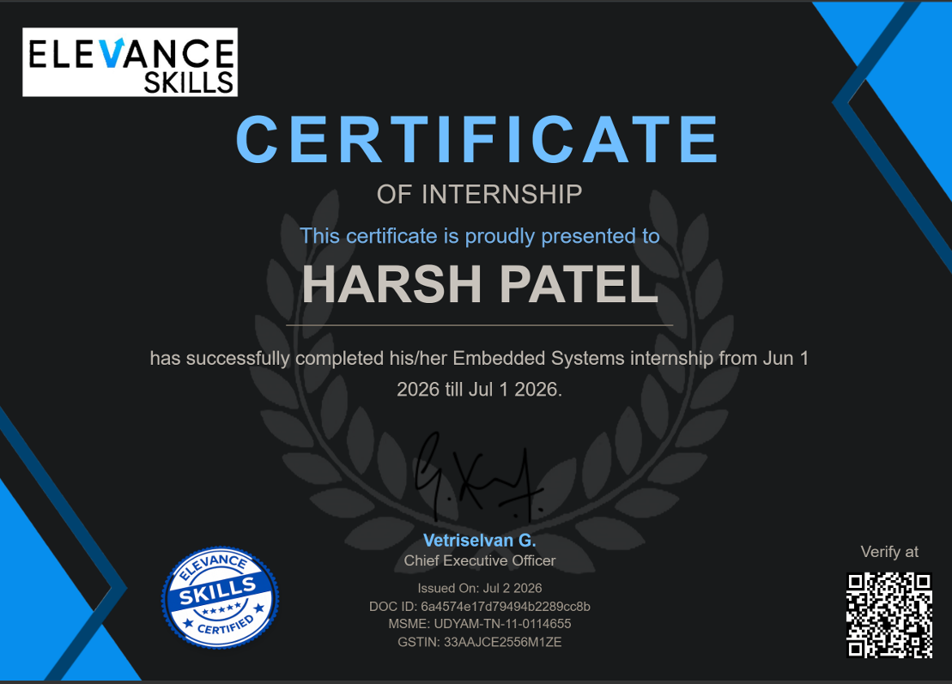
This is to certify that Mr. Harsh Patel (SRN: PES2UG24EC035) has satisfactorily completed the internship project titled “Smart Battery Management System” at Elevance Skills during June 1 to July 1. The work presented in this report was carried out under the prescribed internship framework and is submitted toward the academic requirements of PES University.
The project demonstrates an ESP32-based prototype for multi-cell battery monitoring, protective action, on-device display and cloud telemetry.

________________________
Industry Mentor
JAYANTH V

DECLARATION
I, Harsh Patel (SRN: PES2UG24EC035), declare that this internship project report entitled “Smart Battery Management System” is an original record of work completed by me during my internship at Elevance Skills. The report has not been submitted, in whole or in part, to any other university or institution for the award of any degree or certification.
All technical references and third-party resources used in the preparation of this report have been acknowledged in the references section.

________________________  Student Signature  Harsh Patel | ________________________  Date  01/08/2026

ACKNOWLEDGEMENT
I express my sincere gratitude to Elevance Skills for providing the opportunity to undertake this internship and to explore an applied embedded-systems project. I thank my industry mentor, JAYANTH V, for guidance on project direction and professional practices.
I am grateful to the internship coordinator Dr B Sireesha, Dept. of Electronics and Communication Engineering, PES University- Electronic City Campus for organizing, managing and helping out with the entire process. I am grateful to the Dept. of Electronics and Communication Engineering , PES University- Electronic City Campus for organizing, managing and helping out with the entire process. I take this opportunity to thank Dr. Ajey S N R , Chairperson, Department of Electronics and Communication Engineering, PES University – Electronic City Campus, for all the knowledge and support I have received from the department. I am deeply grateful to Prof. Jawahar Doreswamy, Chancellor, PES University, Dr. Suryaprasad J, Vice-Chancellor, PES University, Dr Nagarjuna Sadineni, Pro Vice Chancellor, PES University for providing me various opportunities and enlightenment every step of the way. Finally, this internship could not have been completed without the continual support and encouragement I have received from my parents and my friends.
ABSTRACT
This report presents the design and implementation of a Smart Battery Management System (BMS) prototype developed during an internship at Elevance Skills. The prototype uses an ESP32 microcontroller to acquire four cell-voltage inputs, estimate pack condition, identify abnormal operating conditions and take protective action through a relay and buzzer. A 16×2 I²C LCD provides immediate local visibility, while Blynk IoT enables remote telemetry and dashboard monitoring.
The firmware is organized as a non-blocking, modular system. Its safety kernel evaluates voltage limits, cell imbalance, weak-cell conditions and sensor plausibility before the runtime manager selects NORMAL, DEGRADED, FAILSAFE or SHUTDOWN operation. Diagnostics and event logs support fault isolation, while configurable thresholds make the prototype suitable for controlled simulation in Wokwi and future physical validation.
The work demonstrates an engineering workflow that combines embedded programming, requirements analysis, safety-oriented logic, human-machine interface design and cloud-connected observability. It is a prototype for learning and demonstration; it is not certified for deployment in a production vehicle or safety-critical battery pack.

TABLE OF CONTENTS
Certificate ................................................................ 1
Declaration ................................................................ 2
Acknowledgement ................................................................ 3
Abstract ................................................................ 4
List of Figures ................................................................ 5
List of Tables ................................................................ 6
1. Company Overview and Internship Context ................................................................ 9
2. Internship Objectives ................................................................ 10
3. Problem Statement and Existing Approaches ................................................................ 11
4. Project Overview and Requirements ................................................................ 12
5. Hardware Architecture ................................................................ 13
6. Software Architecture and Implementation ................................................................ 14
7. Battery Analytics and Safety Kernel ................................................................ 15
8. Runtime Management ................................................................ 16
9. User Interfaces: LCD and Blynk IoT ................................................................ 17
10. Diagnostics and Event Logging ................................................................ 18
11. Testing and Validation ................................................................ 19
12. Results and Discussion ................................................................ 20
13. Challenges Faced ................................................................ 21
14. Learning Outcomes ................................................................ 22
15. Conclusion and Future Scope ................................................................ 23
References ................................................................ 24
Appendix A: Pin Mapping ................................................................ 25
Appendix B: Screenshot Checklist and GitHub Placeholder ................................................................ 26

LIST OF FIGURES
Figure 1. Overall BMS functional architecture
Figure 2. Hardware interconnection and signal flow
Figure 3. Firmware layered architecture
Figure 4. Safety decision flow
Figure 5. Runtime state-transition model
Figure 6. LCD information pages
Figure 7. Blynk cloud telemetry path
Figure 8. Screenshot placeholders

LIST OF TABLES
Table 1. Internship objectives
Table 2. Functional and non-functional requirements
Table 3. Hardware bill of materials
Table 4. GPIO and interface allocation
Table 5. Firmware modules
Table 6. Fault classification and protective response
Table 7. Test matrix
Table 8. Representative results
Table 9. Learning outcomes

1. COMPANY OVERVIEW AND INTERNSHIP CONTEXT
Elevance Skills is presented in this report as the internship organization that supported applied learning in embedded systems, Internet of Things (IoT) and engineering project execution. The internship context emphasized converting a conceptual battery-monitoring idea into a demonstrable prototype with clear requirements, modular firmware, observable behaviour and test evidence.
The project was planned as a learning-oriented engineering prototype. The intern was responsible for requirement interpretation, system partitioning, firmware development, Wokwi-based simulation, interface integration, fault testing and documentation. The resulting artifact is intended to communicate a disciplined engineering approach rather than claim production certification.
Internship dimension | Applied activity | Evidence produced
Domain exposure | Embedded systems, IoT telemetry and safety-oriented logic | Architecture, firmware modules and test plan
Development practice | Incremental integration and non-blocking execution | Working prototype and diagnostics
Professional output | Technical communication and traceability | This project report and repository placeholder

Table 1. Internship context and deliverables

2. INTERNSHIP OBJECTIVES
The internship aimed to develop an end-to-end prototype that makes battery information visible, actionable and traceable. The project objectives were defined before implementation to provide a measurable boundary for the work.
Objective | Success criterion
Monitor individual cells | Acquire and scale four analog voltage channels at regular intervals.
Assess pack condition | Calculate pack voltage, average voltage, imbalance and a rule-based health indicator.
Protect the system | Classify abnormal conditions and command relay/buzzer outputs appropriately.
Provide local visibility | Display concise pack, cell, mode and fault information on an I²C LCD.
Provide remote visibility | Publish selected telemetry and connection status to Blynk IoT.
Support diagnosis | Record event messages and present meaningful operating states.

Table 2. Internship objectives

3. PROBLEM STATEMENT AND EXISTING APPROACHES
Multi-cell battery packs require more than a single pack-voltage measurement. A pack can appear acceptable while one cell is weak, overcharged or significantly different from the others. Without cell-level visibility, unsafe conditions can be missed and maintenance decisions become reactive rather than informed.
The project addresses this gap through a low-cost, simulator-friendly BMS prototype. It samples four voltage inputs, derives pack-level indicators, detects predefined fault conditions and communicates the result locally and through the cloud. The target is an educational proof of concept, not a replacement for certified battery-monitoring integrated circuits or automotive functional-safety processes.
Existing approach | Limitation addressed by this project
Single pack-voltage display | Cannot reveal imbalance or a weak cell.
Manual inspection | No continuous monitoring, alarm or historical context.
Blocking demonstration firmware | Can delay display, connectivity or protection response.
Cloud-only dashboard | Does not provide immediate local fault indication.

Table 3. Problem framing

4. PROJECT OVERVIEW AND REQUIREMENTS
The Smart BMS prototype observes a four-cell series-equivalent model. In Wokwi, potentiometers represent conditioned sensor signals. The ESP32 samples these inputs and runs analytics, protection and presentation tasks without using delay-based control loops. A relay models the isolation path and a buzzer models the audible alert path.

4.1 Functional Requirements
ID | Requirement
FR-01 | Read four independent analog cell-voltage channels.
FR-02 | Compute pack voltage, average voltage and maximum cell spread.
FR-03 | Detect low-voltage, weak-cell, imbalance, over-voltage and sensor-disconnect conditions.
FR-04 | Select a runtime mode and operate relay/buzzer according to fault severity.
FR-05 | Update LCD pages and publish Blynk telemetry without blocking the safety loop.
FR-06 | Produce serial diagnostics and event history for testing.

Table 4. Functional requirements

4.2 Non-functional Requirements
- Non-blocking execution using millis()-based scheduling.
- Readable and maintainable modular firmware structure.
- Simulator compatibility with a migration path to physical sensors.
- Clear separation between measurement, analysis, protection, user interface and telemetry.
- Safe-default behavior: a severe or implausible condition removes the modeled relay output.
1. Overall functional architecture
[Cell inputs / potentiometers]
|
v
[ESP32 acquisition] --> [Battery analytics] --> [Safety kernel] --> [Relay + buzzer]
| | |
v v v
[LCD] [Diagnostics] [Runtime manager]
\____________________|____________________/
[Blynk IoT dashboard]
Figure 1. Overall functional architecture

5. HARDWARE ARCHITECTURE
The hardware configuration uses an ESP32 DevKit as the controller. Four potentiometers in the simulator provide cell-voltage analog inputs. The relay module, buzzer and LCD are output/peripheral devices. On real hardware, voltage-divider networks, filtering, protection components and an appropriate cell-monitoring front end would be required before connecting any battery pack to the controller.
Component | Purpose | Interface
ESP32 DevKit | Main controller; acquisition, logic, Wi-Fi | ADC, GPIO, I²C, Wi-Fi
4 × potentiometers | Simulated cell-voltage sensors | GPIO 34, 35, 32, 33
Relay module | Models pack connect/disconnect action | GPIO 25
Buzzer | Models audible warning | GPIO 26
16×2 I²C LCD | Local display of pack and fault status | SDA 21, SCL 22
Blynk IoT | Remote dashboard and telemetry | Wi-Fi

Table 5. Hardware bill of materials and interfaces
2. Hardware interconnection and signal flow
POT1 -> GPIO34 | POT2 -> GPIO35 | POT3 -> GPIO32 | POT4 -> GPIO33
|
v
ESP32 DevKit
| | |
GPIO25 relay GPIO26 buzzer I²C LCD (21/22)
|
Wi-Fi -> Blynk
Figure 2. Hardware interconnection and signal flow

6. SOFTWARE ARCHITECTURE AND IMPLEMENTATION
The firmware follows a modular structure so that each engineering concern has a limited and testable responsibility. The loop repeatedly services scheduled functions rather than waiting for a fixed delay. This is important because monitoring, display refresh, telemetry and diagnostics must coexist without reducing responsiveness to a fault.
Module | Primary responsibility
Acquisition manager | Read ADC channels, scale values and validate plausibility.
Battery analytics | Compute pack voltage, average, imbalance, status and health estimate.
Safety kernel | Apply fault priority, latch or clear conditions and command protective action.
Runtime manager | Select NORMAL, DEGRADED, FAILSAFE or SHUTDOWN mode.
LCD manager | Rotate local information pages and show alarms.
Telemetry manager | Maintain Wi-Fi/Blynk connection and publish selected values.
Diagnostics manager | Print event messages and retain a compact fault history.

Table 6. Firmware modules
3. Firmware layered architecture
Application: LCD pages | Blynk widgets | Serial diagnostics
----------------------------------------------------------
Control: runtime manager | safety kernel | recovery logic
----------------------------------------------------------
Analytics: pack metrics | imbalance | health | status
----------------------------------------------------------
Platform: ADC | GPIO | I²C | Wi-Fi | Blynk library
Figure 3. Firmware layered architecture

6.1 Main Execution Cycle
At each loop iteration, the firmware services time-based tasks for acquisition, analysis, protection, display, telemetry and diagnostics. The ordering gives safety evaluation precedence over presentation. Any output update is derived from the most recent validated data and active fault state.
Task | Typical scheduling intent | Reason
Acquisition | Fast periodic | Detect changes in cell readings.
Analytics and safety | Immediately after acquisition | Convert measurements into operating decision.
LCD refresh | Moderate periodic | Readable local feedback without flicker.
Telemetry | Slower periodic | Avoid unnecessary cloud traffic.
Diagnostics | On event or periodic | Preserve traceability without serial flooding.

Table 7. Scheduler intent

7. BATTERY ANALYTICS AND SAFETY KERNEL
The analysis layer derives parameters from cell voltages V1 to V4. Pack voltage is Vpack = V1 + V2 + V3 + V4. Average voltage is Vavg = Vpack / 4. Cell imbalance is calculated as Vmax − Vmin. Thresholds are configuration values and must be validated for the actual chemistry, sensor accuracy and operating environment before any physical deployment.
A simple weighted health indicator is used for prototype presentation. It begins at a nominal score and applies penalties for low average voltage, imbalance, weak-cell detection or severe fault occurrence. The displayed score is bounded to 0–100 and should be understood as an engineering indicator, not a certified state-of-health measurement.
Condition | Detection concept | Response severity
Low battery | Average or pack voltage below warning threshold | Informational / NORMAL
Weak cell | One cell lower than minimum operating threshold | DEGRADED
Minor imbalance | Cell spread above warning threshold | DEGRADED
Critical imbalance | Cell spread above severe threshold | FAILSAFE
Over-voltage | Any cell above maximum threshold | SHUTDOWN
Sensor disconnect / implausible input | Reading outside credible range | SHUTDOWN

Table 8. Fault classification and response
4. Safety decision flow
Acquire and validate cell readings
|
v
Severe fault? (over-voltage / sensor disconnect) -- yes --> SHUTDOWN
| no
v
Critical fault? (critical imbalance / hardware fault) -- yes --> FAILSAFE
| no
v
Advisory fault? (weak cell / imbalance) -- yes --> DEGRADED
| no
v
NORMAL
Figure 4. Safety decision flow

8. RUNTIME MANAGEMENT
Runtime management translates technical fault flags into concise operational modes. This separates “what was detected” from “how the system behaves.” The approach makes it easier to explain system behavior on the LCD, Blynk dashboard and serial monitor while retaining individual diagnostic flags for investigation.
Runtime mode | Entry condition | Expected behaviour
NORMAL | No active protection-level fault | Relay enabled in modeled system; normal display and telemetry.
DEGRADED | Weak cell or non-critical imbalance | Keep controlled operation; show warning and increase diagnostic visibility.
FAILSAFE | Critical imbalance or controller-side concern | Move to conservative state; protective indication active.
SHUTDOWN | Over-voltage or sensor-disconnect condition | Relay disabled; high-priority alarm and clear fault display.

Table 9. Runtime-mode definition
Recovery is deliberately conservative. The firmware should require continuously healthy readings for a configured interval before allowing the system to return from a reduced mode. This prevents rapid oscillation when a threshold is crossed repeatedly because of noise or a changing input.
5. Runtime state-transition model
NORMAL <--> DEGRADED <--> FAILSAFE
| | |
| | v
| +--------> SHUTDOWN
| |
+---- healthy interval ---+
All recovery paths require validated readings for the configured period.
Figure 5. Runtime state-transition model

9. USER INTERFACES: LCD AND BLYNK IOT

9.1 LCD Interface
The 16×2 LCD is designed as a compact operator interface. It rotates through pages that show pack voltage and health, paired cell voltages, runtime mode and communication state, and active fault or recovery information. Alarm messages take priority when a severe condition is active.
Page | Illustrative display
1 | Pack 11.39 V | Health 98%
2 | C1 2.93 V | C2 2.90 V
3 | C3 2.77 V | C4 2.79 V
4 | Mode NORMAL | Wi-Fi OK
5 | Faults 0 | Recovery OK

Table 10. LCD page plan
6. LCD information pages
PAGE 1: Pack 11.39V PAGE 2: C1 2.93 C2 2.90
Health 98% PAGE 3: C3 2.77 C4 2.79
PAGE 4: Mode NORMAL PAGE 5: Faults 0 / Recovery OK
Wi-Fi OK
Figure 6. LCD information pages

9.2 Blynk IoT Integration
Blynk IoT is used as a dashboard layer for remote observation. The telemetry manager connects the ESP32 to Wi-Fi, configures Blynk using device credentials and calls the cloud service only when connected. Datastreams can expose cell voltages, pack voltage, health, fault status, runtime mode, relay status and connectivity. Credentials are intentionally excluded from this report and must never be committed to a public repository.
7. Blynk cloud telemetry path
ESP32 -> Wi-Fi station -> Blynk Cloud -> Web / Mobile Dashboard
| |
+---- local LCD + serial diagnostics +---- live datastreams
Figure 7. Blynk cloud telemetry path

[ BLYNK DASHBOARD SCREENSHOT ]
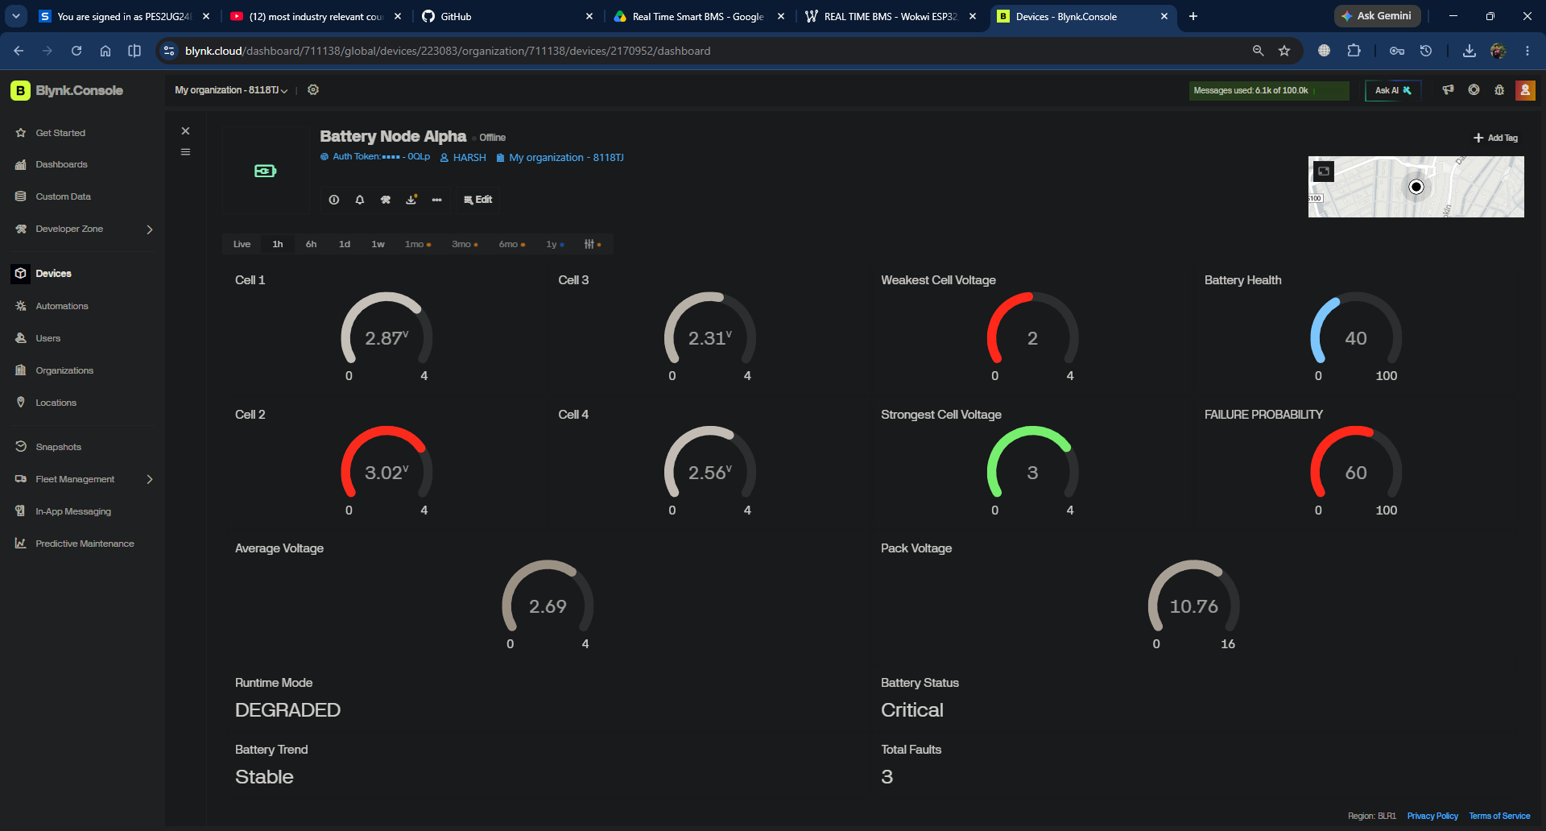

10. DIAGNOSTICS AND EVENT LOGGING
Diagnostics make the prototype easier to test and demonstrate. Each significant event is emitted to the serial monitor using a clear message format. The firmware can retain a small rolling history so that the most recent transitions remain visible after the immediate display has moved on.
Event | Example diagnostic message | Value to verify
Boot | [00:00:01] System initialized | Configuration loaded and outputs safe.
Cloud connection | [00:00:12] Blynk connected | Dashboard changes to online.
Weak cell | [00:01:24] Weak cell detected | Cell ID and measured value.
Relay action | [00:01:25] Relay OFF | Mode and protection state match.
Recovery | [00:01:40] Healthy interval complete | Mode change is deliberate and stable.

Table 11. Representative diagnostic events
A simulator-specific consideration was identified during development: a stationary potentiometer can cause an overly simple frozen-ADC detector to misclassify a healthy, stable voltage as a hardware fault. For the Wokwi prototype, frozen-input detection should therefore be disabled or redesigned so that it validates sensor plausibility rather than merely detecting a lack of variation. This distinction is documented as a test and design limitation.

11. TESTING AND VALIDATION
Testing was conducted using controlled potentiometer changes in Wokwi and inspection of LCD, serial-monitor and Blynk outputs. Test cases focus on observable behavior: correct computation, correct state selection, protective output behavior and continuity of local/cloud interfaces. Threshold values and exact screenshots should be updated to match the final firmware configuration used for submission.
Test ID | Stimulus | Expected result | Status
T01 | Balanced nominal cell inputs | NORMAL; relay enabled; healthy display | [Record]
T02 | One cell lowered below weak threshold | DEGRADED; warning shown and logged | [Record]
T03 | Increase cell spread beyond critical threshold | FAILSAFE; conservative output state | [Record]
T04 | Increase one cell beyond upper limit | SHUTDOWN; relay disabled; alarm active | [Record]
T05 | Force implausible/disconnected reading | SHUTDOWN and diagnostic event | [Record]
T06 | Restore healthy values for recovery interval | Controlled return only after stable healthy interval | [Record]
T07 | Disconnect/reconnect network | Local safety loop remains active; telemetry reconnects | [Record]

Table 12. Validation matrix
[ WOKWI CIRCUIT SCREENSHOT ]
Wokwi circuit showing ESP32, four potentiometers, relay, buzzer and I²C LCD.
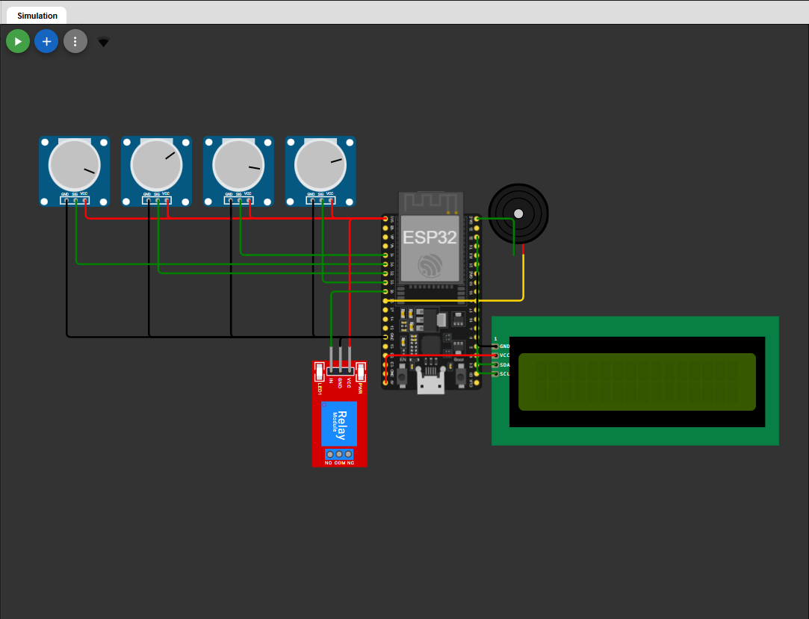

[ LCD AND SERIAL MONITOR SCREENSHOT ]
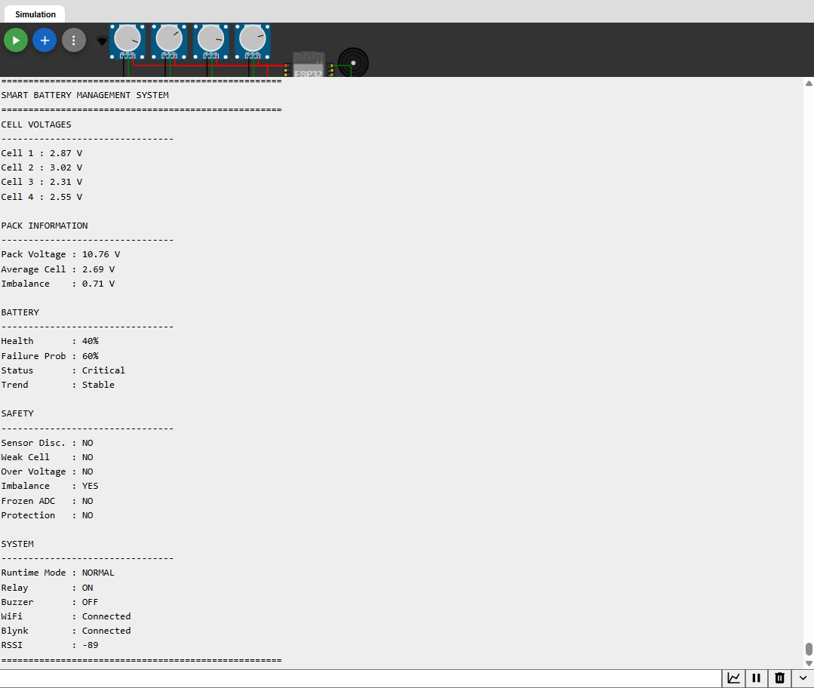

12. RESULTS AND DISCUSSION
The prototype achieved its principal design objective: converting four independent cell inputs into a monitored and explainable battery-state model. The LCD, relay/buzzer model, diagnostics and Blynk telemetry provide complementary views of the same underlying decision. This is valuable because a demonstration can verify both the protective behavior and the information shown to a local or remote user.
Evaluation area | Observed outcome | Interpretation
Monitoring | Four channels are acquired and summarized as pack metrics. | Cell-level visibility is preserved.
Protection | Fault priority selects a distinct operating mode. | Response is explainable and testable.
Local UI | LCD pages present compact, rotating information. | Supports demo without a laptop.
IoT telemetry | Cloud dashboard mirrors selected live values. | Supports remote observation; does not replace safety logic.
Diagnostics | Event messages expose transitions and anomalies. | Reduces time to isolate integration issues.

Table 13. Results summary
The system should be interpreted correctly. Wokwi inputs are a convenient simulation mechanism and do not reproduce all electrical effects of a physical pack, including transient noise, cell temperature, current sensing, balancing behavior, isolation requirements or sensor drift. The work nevertheless establishes a clean baseline from which these capabilities can be added.

13. CHALLENGES FACED
Challenge | Resolution / learning
Cloud connectivity variability | Separated Wi-Fi and Blynk connection handling, added clear connection-status diagnostics and avoided blocking reconnection logic.
False frozen-ADC fault in simulation | Recognized that stable battery voltage is not inherently a failure; marked the logic for simulator-aware redesign.
Multiple concurrent functions | Used millis()-based scheduling to avoid delay-driven interference.
Making safety behavior understandable | Created explicit runtime modes and linked them to visible LCD/Blynk/serial evidence.
Boundary between prototype and product | Documented limitations and avoided claims of functional-safety certification.

Table 14. Challenges and responses

14. LEARNING OUTCOMES
- Embedded C/C++ development for ESP32 using Arduino-compatible libraries.
- Analog acquisition, scaling and the limitations of simulated versus physical sensor inputs.
- I²C display integration and GPIO control for relay and buzzer peripherals.
- Non-blocking scheduling and modular firmware design.
- IoT telemetry design, dashboard observability and credential hygiene.
- Fault prioritization, safe-default behavior and recovery hysteresis.
- Test-case definition, diagnostic logging and technical-report writing.

15. CONCLUSION AND FUTURE SCOPE

15.1 Conclusion
The Smart Battery Management System internship project delivered a complete, demonstrable ESP32-based prototype for four-cell monitoring, rule-based battery analytics, runtime-state management, protective action, local LCD visibility, Blynk IoT telemetry and diagnostic logging. The design uses modular responsibilities and non-blocking scheduling to keep monitoring and safety logic responsive while supporting user interfaces and cloud connectivity.
Most importantly, the project demonstrates an engineering mindset: measurement is separated from interpretation, safety decisions are prioritized over presentation, and every major state change can be observed through more than one channel. The prototype is suitable for academic assessment and portfolio demonstration when final screenshots, values and institution-specific approval fields are added.

15.2 Future Scope
Enhancement | Expected value
Dedicated cell-monitor IC and calibrated dividers | Improves measurement accuracy and electrical robustness.
Current and temperature sensing | Enables power, thermal and more meaningful state estimation.
Passive/active balancing control | Allows corrective action for cell imbalance.
Persistent fault/event storage | Supports post-event analysis and maintenance history.
Improved state-of-charge / state-of-health estimation | Moves beyond rule-based display indicators.
Hardware-in-the-loop and physical-pack testing | Validates behavior under realistic dynamics.
Security hardening | Protects credentials, device identity and cloud data.

Table 15. Future-scope roadmap

REFERENCES
[1] Espressif Systems, ESP32 Series Datasheet and Technical Reference Manual.
[2] Arduino Documentation, Arduino Language Reference and ESP32 Arduino Core documentation.
[3] Blynk, Blynk IoT Platform Documentation and ESP32 library examples.
[4] Wokwi, ESP32 and electronics simulation documentation.
[5] Texas Instruments, Battery Management System design resources.
[6] Gregory L. Plett, Battery Management Systems, Volume I: Battery Modeling.
[7] Relevant university internship-report guidelines and template supplied by PES University.

APPENDIX A: GPIO AND INTERFACE ALLOCATION
Signal | ESP32 pin | Notes
Cell 1 ADC | GPIO 34 | Input-only analog channel in simulation.
Cell 2 ADC | GPIO 35 | Input-only analog channel in simulation.
Cell 3 ADC | GPIO 32 | Analog input.
Cell 4 ADC | GPIO 33 | Analog input.
Relay control | GPIO 25 | Modeled pack isolation output.
Buzzer control | GPIO 26 | Audible-warning output.
LCD SDA | GPIO 21 | I²C data.
LCD SCL | GPIO 22 | I²C clock.

Table 16. GPIO mapping

APPENDIX B: FINAL SUBMISSION CHECKLIST
- Replace [SRN], [Guide Name], [Mentor Name], dates, signatures and programme fields.
- Insert only verified screenshots from the final Wokwi, LCD, Serial Monitor and Blynk setup.
- Update test statuses and threshold values against the final firmware.
- Update the Table of Contents in Microsoft Word after final edits.
- Remove credentials, access tokens and private network data from all screenshots and code.
- Attach any college-required certificate or similarity declaration as directed by PES University.

GITHUB REPOSITORY PLACEHOLDER
Repository URL: https://github.com/harshnp2505/elevance-embedded-systems-internship/tree/main
Recommended repository contents: source firmware, Wokwi Link , README with wiring and setup instructions, dashboard datastream mapping, screenshot evidence and this final report PDF.

[ GITHUB REPO ]
